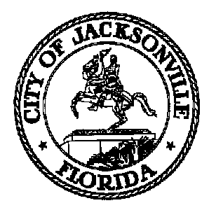

# CITY COUNCIL PAGE PROGRAM

**An Overview**

**Purpose**

The Jacksonville City Council Page Program seeks to give youth ages 10-18 the opportunity to learn about the inner workings of local government and gain valuable experience. The Pages will work before and during a City Council meeting and help with tasks assigned by the Legislative Services Division.

**Target Population**

Current student (ages 10-18)

**Program Outcomes**

The Page experience provides youth with the unique opportunity to work alongside City Council members in the midst of legislative action. Students will increase their understanding of the responsibilities and processes of government and the legislative process.

**Examples of Responsibilities**

* Assisting Council and staff members
* Assisting with legislative needs during Council meeting
* Distributing legislative documents
* Distributing Public Comment materials

**City Council Page Program Schedule**

Prior to Meeting Day

* Complete pre-orientation seminar (available online)
* Tour City Hall and possible meeting with district Council Member

On Meeting Day

* Arrive at City Hall between 4:00 and 4:15 p.m. on the 2nd or 4th Tuesday of the month for the Council meeting
* Be assigned responsibilities by the Legislative Services Division
* Meet and have an opportunity to be photographed with the Council President and receive a commemorative certificate prior to the meeting
* Attend the meeting beginning at 5:00 p.m. to carry out assigned duties
* Participants do not need to stay for the full meeting