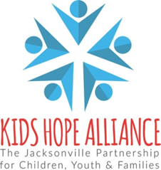

PUBLIC NOTICE
KIDS HOPE ALLIANCE
CEO SEARCH COMMITTEE MEETING
IN-PERSON MEETING NOTICE
December 3, 2025 9:30 a.m.

Notice is hereby given that four members of the the Kids Hope Alliance Board will meet in-person on December 3, 2025 at 9:30 a.m. This meeting will take place in the Kids Hope Alliance Board Room. The agenda is available here.

PHYSICAL LOCATION
December 3, 2025 at 9:30 a.m.
Kids Hope Alliance Board Room, 2nd Floor
1095 A. Philip Randolph Blvd.
Jacksonville, FL 32206

Public comments will not be considered as there are no actionable items on the agenda. Pursuant to the Americans with Disabilities Act, accommodations for persons with disabilities are available upon request. Please allow 1-2 business days notification to process; last minute requests will be accepted but may not be possible to fulfill. Please contact Disabled Services Division at: V(904) 255-5466, TTY-(904) 255-5476, or email your request to karat@coj.net.
Please contact Deborah Sibley by telephone at (904) 255-4449 or by email at sibleyd@coj.net if you have any questions regarding this notice.

