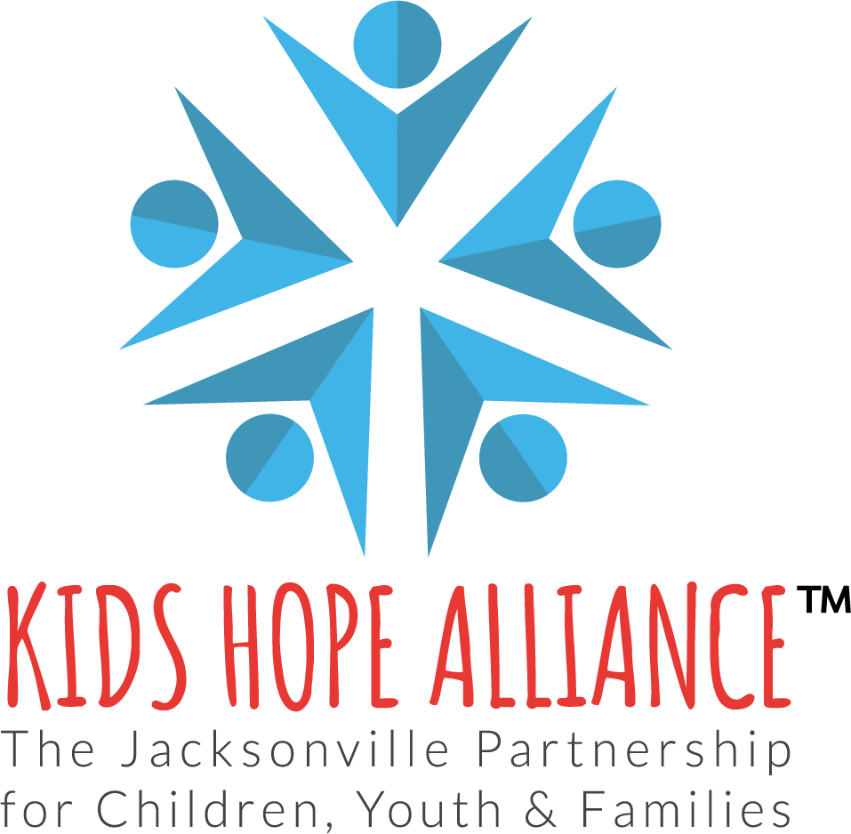

Pay for Performance (PFP) Attestation Form

I acknowledge that I have received, reviewed, and understand the Kids Hope Alliance Pay for Performance (PFP) Reference Guide dated July 29, 2025.
- I understand the requirements for the use of program funds as outlined in the PFP Reference Guide, stating services must align with the approved scope of work, governing laws/regulations, and the approved budget.
- I understand the definitions and requirements related to my contractual method of payment i.e. Units of Service (UOS), Cost Reimbursement, or Deliverables.
- I will comply with all reimbursement procedures, deadlines, and required documentation for proof of service as outlined in the guide.
- I understand that failure to submit timely and accurate reimbursement requests or supporting documentation may result in corrective action, delayed payments, or disallowance of expenditures.
By signing below, I certify that I and my organization will comply with the policies, procedures, and requirements outlined in the PFP Reference Guide and in our contract with Kids Hope Alliance.
Agency/Organization: ______________________________________
Program Name: ______________________________
Authorized Representative (Print): _____________________________
Title: ______________________________________________________
Signature: _________________________________________________
Date: _____________________________________________________

