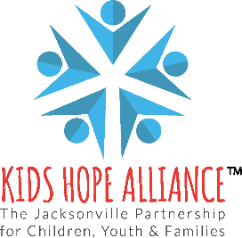

PUBLIC NOTICE
KIDS HOPE ALLIANCE
FINANCE COMMITTEE MEETING
IN-PERSON MEETING NOTICE
September 18, 2024, 2:00 p.m.

Notice is hereby given that the Kids Hope Alliance Finance Committee meeting will meet in-person on September 18, 2024 at 2:00 p.m. This meeting will take place in the Kids Hope Alliance Board Room and the agenda will be available 48 hours prior to the meeting.

PHYSICAL LOCATION
September 18, 2024 at 2:00 p.m.
Kids Hope Alliance Board Room, 2nd Floor
1095 A. Philip Randolph Blvd.
Jacksonville, FL 32206

Persons attending this meeting in-person will be given an opportunity to provide public comment during the designated public comment period provided they fill out a blue speaker card at the meeting. Interested persons who cannot attend the meeting, but wish to submit public comments to be read during the public comment period of the meeting regarding any matter on the agenda for consideration at the meeting, may do so by emailing Patricia Hughes at phughes@coj.net no later than 24 hours before the start of the meeting.
Pursuant to the Americans with Disabilities Act, accommodations for persons with disabilities are available upon request. Please allow 1-2 business days notification to process; last minute requests will be accepted but may not be possible to fulfill. Please contact Disabled Services Division at: V(904) 255-5466, TTY-(904) 255-5476, or email your request to karat@coj.net.
Please contact Patricia Hughes by telephone at (904) 255-4533 or by email at phughes@coj.net if you have any questions regarding this notice.

