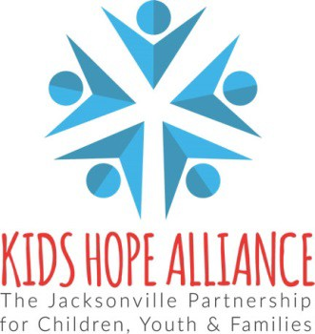

BOARD POLICY
ADVANCE PAYMENT POLICY

Section: | Finance
Subject: | Advance Payments and Recouping Advance Payments
Effective Date: | August 18, 2021 | Review Date: | November 16, 2022
Approved: KHA Board, November 16, 2022

AUTHORITY:
Ordinance Code, Section 77.109(a)(9) – Kids Hope Alliance Powers:
KHA in developing, overseeing, implementing and managing the Essential Services Plan for Kids under this Chapter shall have the following powers to: Advance funds up to 25 percent of the contract amount to Providers, Small Providers and Agencies, subject to applicable Board rules and policies, for the purpose of providing the start-up funds necessary to commence services.

POLICY:
The CEO, or the CEO’s designee, may approve advances in accordance with Section 77.109(a)(9), Ordinance Code, and this Policy. The amount of an advance shall not exceed 25 percent of the contracted amount for the then current term of the contract.

If a Provider, Small Provider or Agency is requesting an advance, and the contract is funded by the Kids Hope Alliance with funds from a grant or other source of funds outside the City of Jacksonville, the amount of the advance shall only be available to the extent the funds have been received and appropriated by the Jacksonville City Council and will follow the guidelines of the granting agency.

PROCEDURE:

1. Upon execution of a contract with the Kids Hope Alliance, the Small Provider, Provider or Agency will submit an Advance Payment Option Form indicating the percentage they are requesting, which can range from 0% to 20% (or other amount if funded with outside funds). KHA Finance will forward a payment request to the City of Jacksonville General Accounting Division for processing of the requested advance.

Page 1 of 2
Policy #:

RECOUPING THE ADVANCE:

The advance shall be recouped in accordance with the following:

- The advance payment shall be recouped starting in the payment period (month or quarter) that is halfway through the current term of the contract or the program. For example, for a 12-month contract that begins August 1 and is payable monthly, recoupment of the advance will begin by reducing the monthly payment for February. If the halfway point is in the middle of a payment period, recoupment of the advance will start in the following payment period. For a 12 month contract with a program that only runs the length of the school year, the repayment of the advance would begin starting month 5.

The advance will be repaid during each payment period remaining under the contract in equal installment amounts determined by dividing the total amount of the advance by the total payment periods remaining in the current term of the contract. If the amount otherwise payable for any payment period is not sufficient to cover the applicable recoupment amount, the balance shall be paid from the next monthly or quarterly payment amount. The intent is to repay the advance in full by the end of the current contract term or end of program and to make no other advances or payments for any renewal term, program or new contract until the advance has been repaid in full.

- The CEO may extend the advance payback period as needed based on extenuating circumstances, such as natural disasters or extreme financial hardship, provided that the CEO, or the CEO’s designee, and the Small Provider, Provider or Agency have worked out a repayment plan that is acceptable to KHA in the CEO’s reasonable discretion.

- A Small Provider, Provider or Agency will not receive an advance or payments for any renewal term, or any new contract for essentially the same services, until the advance for a prior term or contract is fully recouped.

- A Small Provider, Provider or Agency at any time may elect to pay back the advance sooner than required under this Policy.

