Start/Submit YTTF Application
- Select the Youth Travel Trust Fund option.

- Click on the New Application (YTTF) button.

- You will be required to complete and pass an eligibility questionnaire that consists of 7-8 questions before you can proceed to the YTTF application.

- Sign and save your questionnaire.
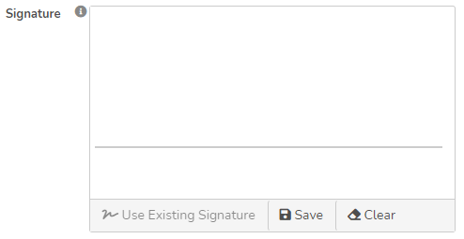

- Based on the answers provided, you’ll be given one of two options:
  - If your organization doesn’t meet the YTTF requirements, you’ll receive the following message:
  - If your organization meets the YTTF requirements, you’ll be able to proceed with the application process.

- Fully complete the application, the following information will be requested.
  - Organization Information
  - Project Information
  - Budget Information
  - Award Criteria
  - Post Travel Reports

- Once all the requested information has been filled in, click the Save button.
- The application will go through three stages of approval, at anyone of these stages the application rejected for adjustments. An email notification will be sent to the submitter, if the application is rejected.

