Registering – Requesting YTTF Access

- Navigate to the Youth Travel Trust Fund (YTTF) page on the KHA website, by clicking on Portals in the top right corner.
- Select Youth Travel Trust Fund on the right side of the screen.
- Click on the provided link, that will direct you to the YTTF registration page.
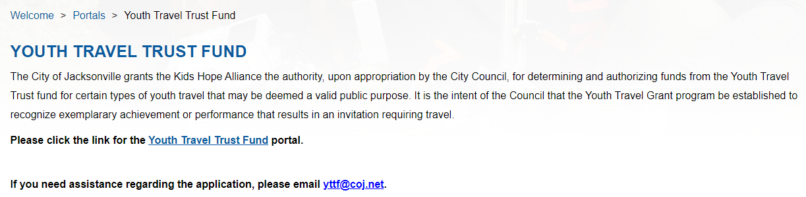
- Click on Register Now link.
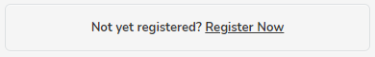
- Complete the registration form, in the comment section indicate the reason for your request.
(Ex: Youth Travel Trust Fund Access)
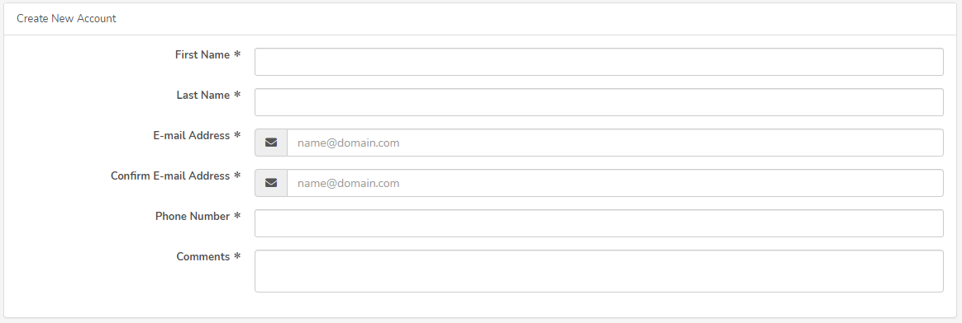

- Click the Register button below once you have filled in the registration form.
- The following message will generate, notifying you that the SAMIS team administrators will receive and review your request:
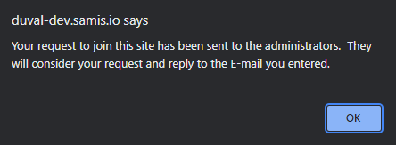
- Once the SAMIS team administrators reviews your request, you will receive one of the two emails below.
- If the request is approved, you will receive an email notification providing you with your username and password like the one below:
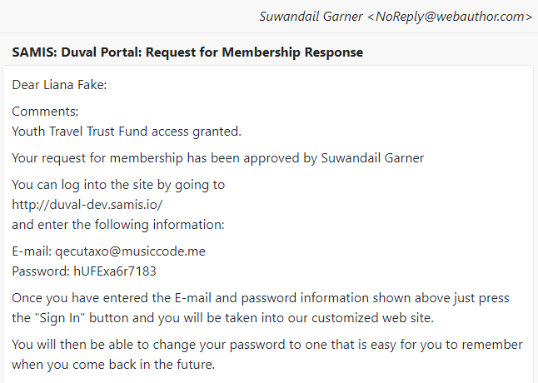

- If the request is rejected, you will receive an email notification like the one below:
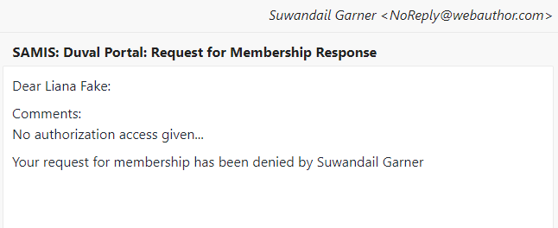
*If your request is rejected, an explanation will be provided in the comment section of your rejection email. Correct all issues stated and resubmit access request for re-review.
- Navigate back to the login page, input the Login ID (email) and Password provide in your approval request email.
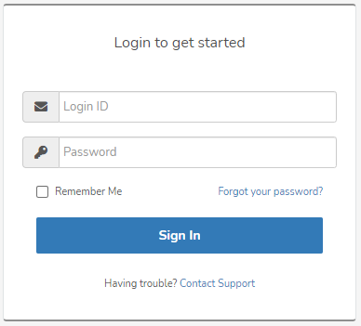
- The following prompt will occur, read and review the terms and conditions, then click the Agree button to proceed.
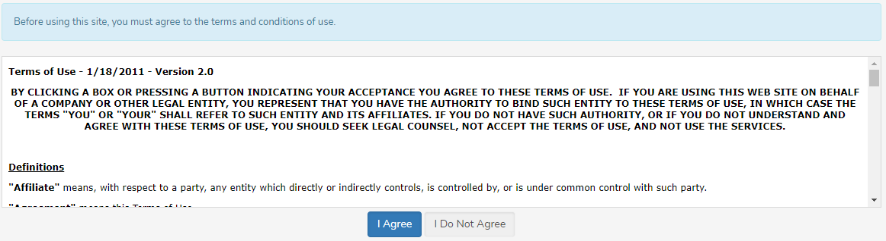
- You will then be prompted to choose a password that only you will know, click the Change My Password button once your decision has been made.
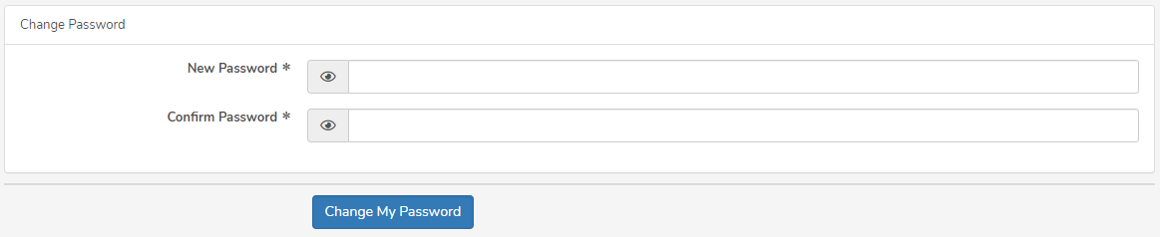
- Your chosen password will be saved, and you’ll be taken to your SAMIS dashboard to start a Youth Travel Trust Fund application.

